Types of Theodolites
Theodolites can be differentiated either by their angle reading systems or the precision of their angle reading system, (which are generally related). Two types of theodolites commonly used and defined by their precision are the 1" theodolite and the 20" theodolite.
There are three types of reading systems in use in modern theodolites: direct, micrometer and electronic.

Direct Reading System
The direct reading type, shown in Figure 1, projects the internal glass circle onto an index mark and the reading is interpolated directly from the circle. These types of theodolites are generally limited in their precision and can be interpolated to around 0.5 minutes of an arc.
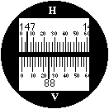
Figure 1: Direct Reading
Reading 147° 05' H, 88° 25'

Micrometer Reading System
Micrometer reading systems can enable precisions up to decimals of a second of arc, and instruments with a resolution of around 10 seconds of arc are common. The reading system uses a parallel plate micrometer to shift the circle reading from its natural position to coincide with that of the index mark, and the amount of shift can be read off an auxiliary scale. A typical reading from a micrometer theodolite is shown in Figure 2.
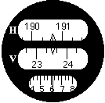
Figure 2: Micrometer Reading
Reading 190° 46' 10"
Go to the next page to view an animated sequence showing how to read angles from a 1" theodolite using a micrometer.

Electronic Reading System
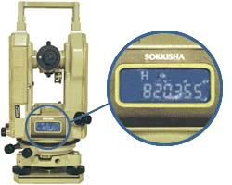 | More recently, electronic theodolites have been developed using microprocessor systems to count divisions of encoded circles and to convert this to an angular reading. The instruments are identical to 'conventional' theodolites but the angle readings are generally displayed on the outside of the instrument on LED or Liquid Crystal display panels. A major benefit of this type of theodolite is that it is usually possible to get access to the data directly in digital form, which offers the possibility of electronic storage and manipulation of the measurements. These theodolites can also incorporate an EDM for the simultaneous measurement of distance, and are known as total stations or electronic tacheometers.

